**CSE103L Circuits & Systems-I Lab**

**Circuits And System 1**

**LAB REPORT # 5**

2020

**Submitted to:**

**Engr. Faiz Ullah**

**Submitted by:**

**TAYYABA**

**Registration No:**

**19PWCSE1854**

**Semester: 2nd**

**Section: C**

“On my honor, as student of University of Engineering and Technology, I have neither given nor received unauthorized assistance on this academic work.”

Student Signature: ______________

Tuesday, March 24, 2020

**Department of Computer Systems Engineering**

**University of Engineering and Technology, Peshawar**

**ASSESSMENT RUBRICS LAB # 5**

**Verification of KVL using breadboard**

|  |  |  |  |  |  |
| --- | --- | --- | --- | --- | --- |
| **LAB REPORT ASSESSMENT** | | | | | |
| **Criteria** | **Excellent** | **Average** | | **Nill** | **Marks Obtained** |
| 1. **Objectives of Lab** | All objectives of lab are properly covered  [Marks 0.5] | Objectives of lab are partially covered  [Marks 0.25] | | Objectives of lab are not shown  [Marks 0] |  |
| 1. **Kirchoff’s Voltage Law**   **(Statement, Mathematical Expression, Circuit Diagram)** | Correct KVL statement and mathematical expression is written. Circuit diagram shown is correct and properly labeled  [Marks 1] | | KVL statement or mathematical expression or circuit diagram is missing or circuit diagram is not properly labeled  [Marks 0.5] | |  |
| 1. **Apparatus Used** | All equipment and electrical components used are shown  [Marks 1] | Equipment and electrical components are partially shown and some of the components are missing [Marks 0.5] | | Equipment and electrical components used are not shown  [Marks 0] |  |
| 1. **Procedure** | All experimental steps are shown in detail  [Marks 1.5] | Some of the experimental steps are missing [Marks 1] | | Experimental steps are missing  [Marks 0] |  |
| 1. **Observations & Calculations** | All experimental results are completely shown in form of table for both cases of using same resistors and for different resistors with varying applied source voltage  [Marks 4] | Experimental results are partially shown and some of the observations are missing  [Marks 2] | | No experimental results are shown  [Marks 0] |  |
| 1. **Analysis** | Analysis and discussion about all experimental results are shown  [Marks 2] | Analysis and discussion about experimental results are partially shown  [Marks 1] | | Analysis is not shown  [Marks 0] |  |
| Total Marks Obtained:__________    Instructor Signature: ______________________ | | | | | |
|  | | | | | |

**VERIFICATION OF KVL USING BREADBOARD**

**Objectives of Lab**

* To get familiar with use of breadboard.
* To get knowledge of Kirchhoff’s Voltage Law (KVL).
* To verify KVL using breadboard.

**KIRCHHOFF’S VOLTAGE LAW (KVL)**

Kirchhoff’s voltage law states that,

The sum of all voltages or potential differences in an electrical circuit loop is 0.

**Mathematically:** ΣV = 0.

While applying KVL, the rise in potential is taken as positive and the fall in potential is taken as negative. The KVL helps in finding the analogous electrical resistance and impedances of the complex system. It also determine the current flowing through each branch of the network.

Note here that the term “algebraic sum” means to take into account the polarities and signs of the sources and voltage drops around the loop.

**Electric Circuit**

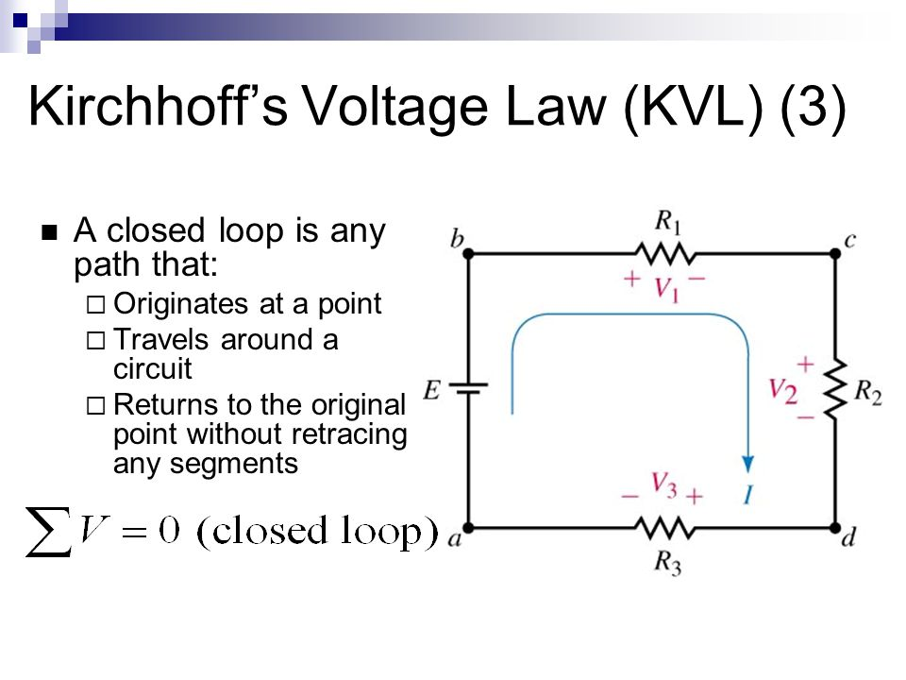

**Apparatus**

* Breadboard
* Connecting wires
* Digital Power supply
* Different Resistors
* Digital multimeter

**Procedure**

* Connect three resistors of same value in series to each other on a breadboard.
* Apply 5V to these resistors.
* Now measure the voltage across all three resistors through digital multimeter.
* Voltage across these resistors will also be equal to 5V.
* Now find voltage across each resistor individually.
* Similarly apply 10V, 15V and 30V to resistors and observe the results.
* Now use three different resistor and note and observe the result.

|  |  |  |  |  |  |  |  |  |  |
| --- | --- | --- | --- | --- | --- | --- | --- | --- | --- |
| **USING SAME RESISTORS** | | | | | | | | | |
| **S.NO** | **Input voltage Vs** | **V1** | **V2** | **V3** | **V=V1+V2+V3** | **R1** | **R2** | **R3** | **Error= $100×$ $\frac{V_{S}-V}{V_{S}}$** |
|  | 6.08V | 2.01V | 2.05V | 2.01V | 6.07V | 330Ω | 330Ω | 330Ω | 0.164% |
|  | 12V | 4V | 4.1V | 3.2V | 11.3V | 330Ω | 330Ω | 330Ω | 5.833% |
|  | 17.41V | 5.91V | 5.94V | 5.82V | 17.37V | 330Ω | 330Ω | 330Ω | 0.2297% |
|  | 23.6V | 7.8V | 7.9V | 7.7V | 23.4V | 330Ω | 330Ω | 330Ω | 0.847% |
|  | 35.2V | 11.6V | 5.82V | 11.6V | 35.1V | 330Ω | 330Ω | 330Ω | 0.284% |

|  |  |  |  |  |  |  |  |  |  |
| --- | --- | --- | --- | --- | --- | --- | --- | --- | --- |
| **USING DIFFERENT RESISTORS** | | | | | | | | | |
| **S.NO** | **Input voltage Vs** | **V1** | **V2** | **V3** | **V=V1+V2+V3** | **R1** | **R2** | **R3** | **Error= $100×$ $\frac{V_{S}-V}{V_{S}}$** |
|  | 35.3V | 1.4V | 30.3V | 3.6V | 35.3V | 330Ω | 37K | 560Ω | 0% |
|  | 23.7 | 0.9 | 20.3 | 2.4 | 23.6 | 330Ω | 37K | 560Ω | 0.421% |
|  | 12 | 0.4 | 10.36 | 1.22 | 11.98 | 330Ω | 37K | 560Ω | 0.16% |
|  | 6.15 | 0.25 | 5.27 | 0.63 | 6.15 | 330Ω | 37K | 560Ω | 0% |
|  | 12 | 0.5 | 10.3 | 1.3 | 12.1 | 330Ω | 37K | 560Ω | 0.83% |

**Analysis**

This can be seen from our experiment that while using same resistors, voltage is equally divided across individual resistor and the sum of voltages across all resistors is equal to source voltage. There is a little difference in values due this is expected due to experimental error when using different devices. Similarly while using different resistors, voltage is unequally divided across each resistor but the sum of voltages across each resistor is equal to the source voltage. Hence KVL is verified.